

ITEC 2706 R&S

GROUP NUMBER: 19

Project Title: Serene Mind.

By

Naga Shishira (229606530),

Durva Kamdar (229625160),

Gurkirpal Singh (229653710),

Divy Patel (229556100),

Olivia Alex (229653770).

**Project report outline**

**ITEC 2706**

1. **What is it?**

Serene Mind is a professional-grade self-help and mental health care app designed to provide users with accessible, affordable, and effective mental health support. The Smart Mobile Technologies in Mental Health Systems project is a research initiative that leverages various mobile technologies, including user-friendly interfaces, sensors, AI and machine learning, video conferencing, virtual reality, frameworks, and chatbots, to deliver personalized mental health interventions.

This project is founded on the premise that mental health care is often inaccessible and expensive, and that mobile technologies can help to bridge these gaps. By providing individuals with greater control over their mental health, remote access to mental health services, and personalized interventions tailored to their specific needs, mobile technologies like Serene Mind can significantly improve mental health outcomes.

To this end, the Serene Mind app includes features such as the Goals section, which monitors physical activity and sleep, important indicators of mental health status. The app also provides access to remote therapy sessions, counseling, and other mental health services via video conferencing, making it easier for individuals in remote or underserved areas to receive care.

This initiative may involve developing new technologies or adapting existing technologies to meet the specific needs of mental health care. Ultimately, the goal of this project is to create a comprehensive, effective, and accessible mobile-based mental health care system that improves the lives of individuals struggling with mental health issues.

1. **What are the objectives? / What problems are solved?**

**Objective-**

* To enhance mental health monitoring and management: Smart Mobile Technologies like this mental health system is to track and monitor an individual's mental health, including their mood, behavior, and other metrics. This data can then be used to provide personalized recommendations and support.
* Resolve the limited access to mental health services: Many people, particularly those in rural or remote areas, do not have access to mental health services due to a lack of mental health providers or limited transportation options. so may this application could help them in many possible ways.
* Providing accessible and affordable mental health support: Mobile technologies can increase access to mental health services for people who may not have access to traditional mental health services due to geographical, financial, or social barriers.

**Problem solved-**

* To improve access to mental health services: the main objective behind this Mental Health system that we are trying to make with the help of Smart Mobile Technologies is to provide individuals with remote access to mental health services, including therapy, counseling, and support groups.
* Lack of mental health education and awareness: Many individuals may not be aware of mental health conditions or may not know how to identify or moreover, how to manage them. Smart Mobile Technologies as mental health system can provide education and awareness about mental health issues, reducing disgrace and improving mental health outcomes.

1. **What mobile technologies are employed in it?**

Serene Mind employs a range of mobile technologies to provide accessible and effective mental health care to users.

1. Mobile operating systems such as Android and iOS are the primary platforms for Serene Mind, with each offering unique features that cater to different target audiences and budgets.
2. Programming languages such as Java, Swift, and Kotlin may be used in the development of Serene Mind, depending on the platform and the preferences of the development team.
3. Frameworks and libraries such as React Native, Xamarin, and Flutter are used to streamline the development process, reducing development time and costs while maintaining high-quality standards.
4. Mobile sensors: mobile sensors such as GPS, accelerometer, gyroscope, and heart rate monitors are integrated into the app to collect data on users' physical activity, location, and physiological responses. Accelerometer sensors can detect movement and provide insights into physical activity levels, sleep patterns, and overall daily activity. Other sensors like GPS, can track location and provide insights into outdoor activities, and heart rate sensors, can provide insights into stress levels. This data is used to track symptoms, monitor progress, and provide personalized recommendations.(bush, hoyt, & Armstrong, 2019)
5. Push notifications are another mobile technology employed by Serene Mind to remind users to take medication, complete therapy exercises, or engage in self-care activities. By harnessing the power of these technologies, Serene Mind provides a comprehensive and effective mental health care solution that empowers users to take control of their mental well-being.

**4. What types of connectivity/communication technology does it use?**

1. Wi-Fi Connectivity

Wi-Fi connectivity can be used to establish a stable and fast connection between the application and remote servers or other devices. This can be useful for data transfer, communication, and remote monitoring. Wi-Fi connectivity can also enable access to online resources such as mental health information, support groups, and self-help resources.

1. Bluetooth Connectivity

Bluetooth connectivity can be used to enable communication and data transfer between the application and other Bluetooth-enabled devices such as wearable health monitoring devices or other mobile devices. This can be useful for remote monitoring, data collection, and tracking of mental health symptoms. (Technology and the Future of Mental Health Treatment, n.d.) (Kohlin & Sleasar, 2022)

1. Video Conferencing

Video conferencing technology can be used to enable remote consultations with mental health care professionals, providing a more convenient and accessible way for individuals to receive mental health support. Video conferencing is also the technology that we are using for remote therapy sessions, counseling, and other mental health services.

**5. Challenges faced.**

* We tried to make a project that is visually appealing and pleasant, for which we had to do a bit research to figure out the colours and patterns of the user interface that are light to the mind of the user.
* We had to do extensive research on all the things that subsequently effect the mental health of a person, which led us to include a ‘Journal’ page and ‘Goals’ page in our app to help the user figure out about the actions that are eventually affecting their mood or sanity.
* We searched for reasons and factors that are limiting the users from seeking or attaining the medical or empathetical help from the recognised resources. Lack of awareness and Lack of accessibility are the reasons we have come across during our investigation, to resolve which, we decided to provide a remote mental health care through our online counselling from a professional counselor, trying to help the user to understand and deal with their emotional difficulties sanely.
* Memory Management: We wanted the app to occupy least space for the benefit of the user’s device memory management.
* Battery Consumption: As a Mental Health Fitness app involves lots of interaction with the user to take the input, analyze and revert with results, the app consists lots of activity tracking technologies that consume the device battery in excessive levels.

**6. Label a diagram of the system**

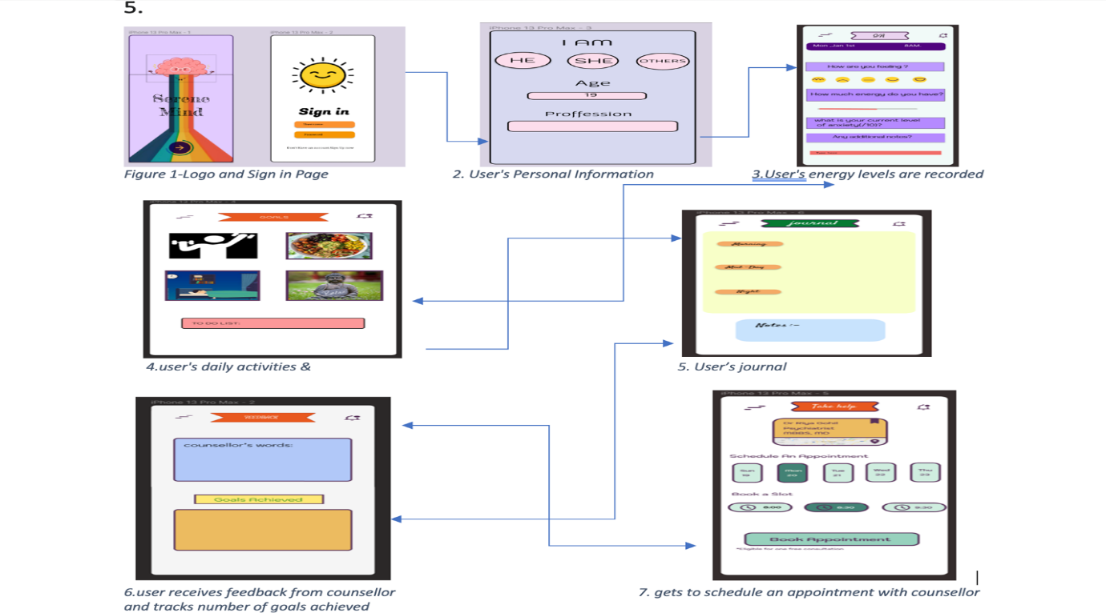

# References

bush, N., hoyt, T., & Armstrong, C. M. (2019, May). *Smartphone Apps for Psychological Health: A Brief State of the Science Review*. Retrieved from 1. <https://www.researchgate.net/publication/328816717_Smartphone_Apps_for_Psychological_Health_A_Brief_State_of_the_Science_Review>

Kohlin, S., & Sleasar, M. (2022, March 30). *Mental Health App Development in 2023: Complete Guide*. Retrieved from<https://onix-systems.com/blog/mental-health-app-development>

*Technology and the Future of Mental Health Treatment*. (n.d.). Retrieved from <https://www.nimh.nih.gov/health/topics/technology-and-the-future-of-mental-health-treatment>